User Documentation for MSTC Attendance Tracking Program – Capstone 2018

# Step 1: Download your student list from MSTC Blackboard

*Note: This step is optional, you can add your students individually if you wish.

Before you start using the Attendance Tracking you can obtain your student list from Blackboard by following the pictures below.

## In the Grade Center, under “Work Offline”, select “Download”.

## Make sure to select “User Information Only” for the data type and “Comma” for the delimiter type.

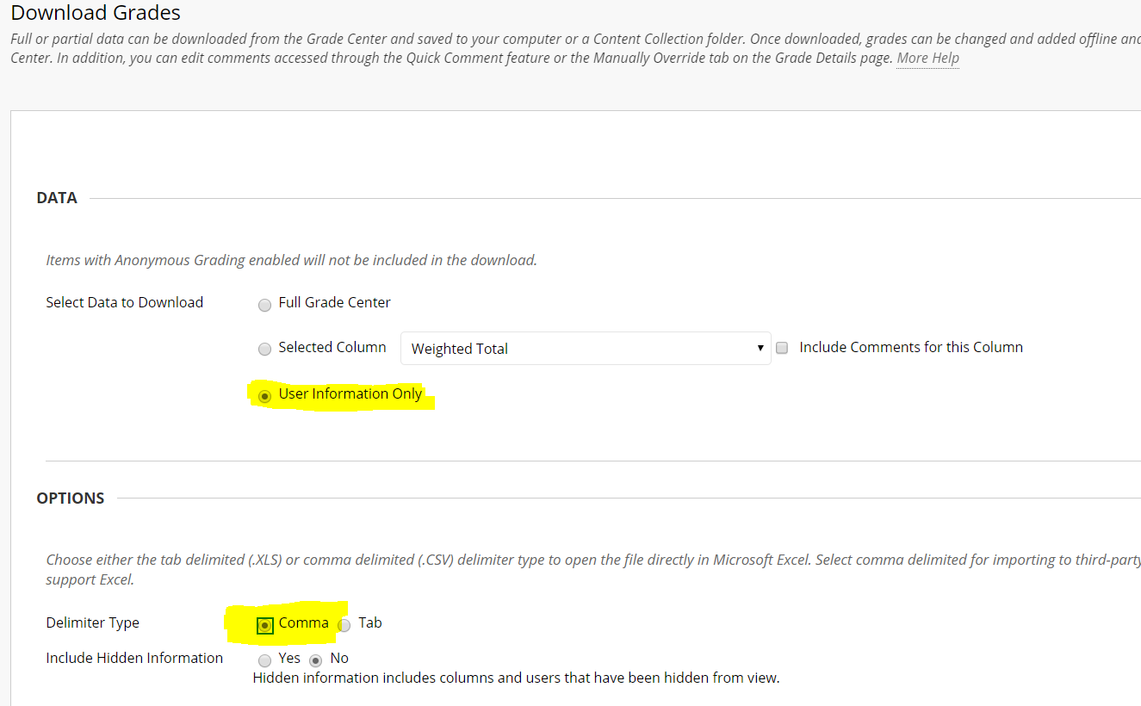

## Ensure your spreadsheet is in this format by opening the document in Microsoft Excel.

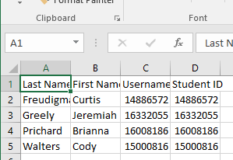

## This step is complete, move on to step 2.

# Step 2: Sign Up and Log In

## If no user is logged in, the Welcome page will display

## 2. Clicking “Sign Up” will show the following page. Fill out the information, including your MSTC instructor id and email, and click submit.

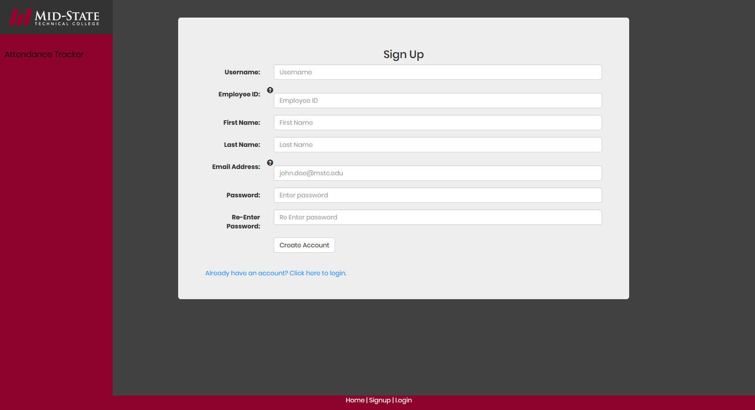

## Once you sign up, you will receive an email to your MSTC email account that has a confirmation link. Once you click on the link, a confirmation page on the website will show and have you complete your first log in.

*Note: If you have not received an email within 24 hours of signing up, please check your trash or spam folder.

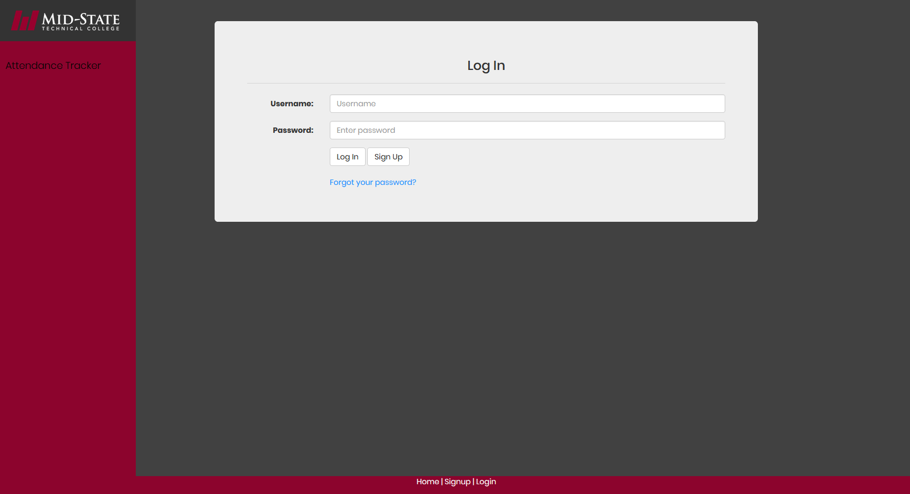

## Once you have logged in, a second Welcome screen will display.

## Clicking the blue “here” button will lead us to our next step.

# Step 3: Managing Classes and Students

## Once this page is displayed, fill in the course name and id. The course name can be something different than the official name to make the attendance process smoother.

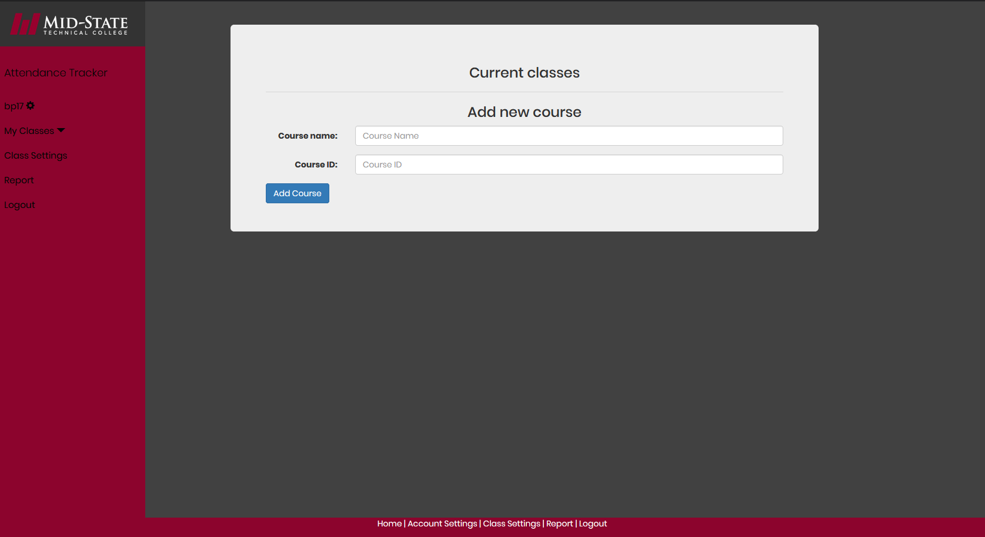

## Once the classes are added, they will display above the form to add a course. By clicking on the name, the specific course’s manage course page will display.

## On the Manage Course page, students can be added individually, or by importing the student list spreadsheet from step 1. To import students individually, enter the student’s name and id number in the top form and click “Add Student”.

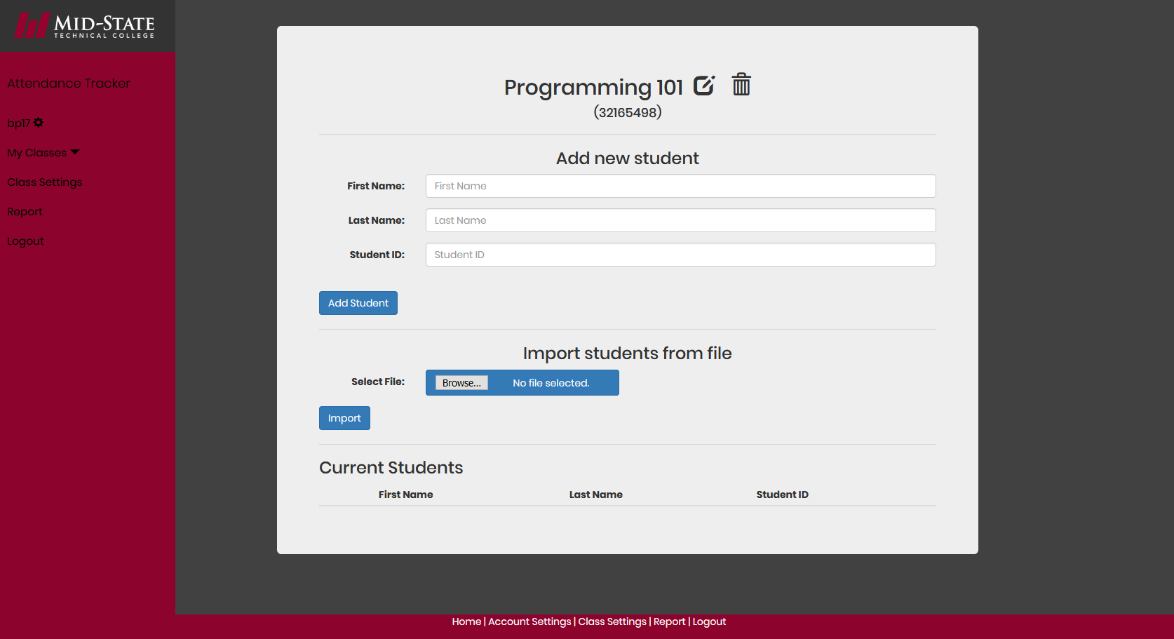*Note: if you have not downloaded the CSV spreadsheet, please see step 1.

## To import students from the CSV file, click the browse button and select the document. Press the “Import” button to add them to the class.

## 5. Once a student is added, it will display below the “Current Students” section.

## 

## 6. To modify a student’s last name, click on the pen and paper icon next to the student’s name.

## 7. To delete a student, click the trash can icon next to their name. A new screen will appear, with a popup screen that will ask if you want to delete the student.

## 8. To edit the course name, select the pen and paper icon next to the course’s name.

## 9. Once all your classes and students have been added, it’s time to take attendance.

# Step 4: Taking attendance

## 1. To take attendance, select the “My Classes” drop down menu on the left side bar and select the class taking attendance in.

## 2. Attendance will automatically be set to present, as there are generally more students present than absent. To take attendance, click on the green slider to change it to absent. There is also a comments area if comments are needed.

## 

## 3. Once attendance is submitted, the page will display the correct attendance for each student. Comments are per student, per class. For example, the comment above will remain in that text box until the class is deleted. It will not show for any other course or student, though.

## 4. Taking attendance is complete now.

# Step 5: Reporting

## 1. Clicking on “Reporting” on the left side navigation bar will bring you to the Reporting page. By selecting a class, you can view all of the attendance in one table, with the absences highlighted red and presences green to clearly show the differences.

## 2. At the end of the semester, if financial aid needs to see who was absent when, this is a great way to record that information.

# Step 6: Account Management

## 1. To change your last name, enter the new name and click “Change Last Name”.

## 2. To change your password, click on the “Changing your Password?” link at the bottom of the Account Settings page. Enter a new password and click ok on the popup verifying the password change to successfully complete this step.